How to root your mobile

Step 1: Download the Kingroot app from the link provided below.
Download: Kingroot
https://forum.xda-developers.com/devdb/project/dl/?id=13663
Step 2: Make sure you have enabled apps to be installed from external sources.
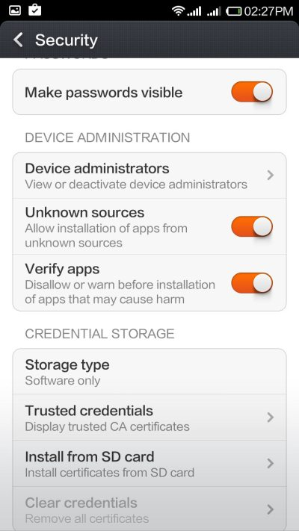
- Step 3: Install Kingroot on your phone.
- Step 4: Once Kingroot is installed on your phone, it will check is your phone is rooted or not.
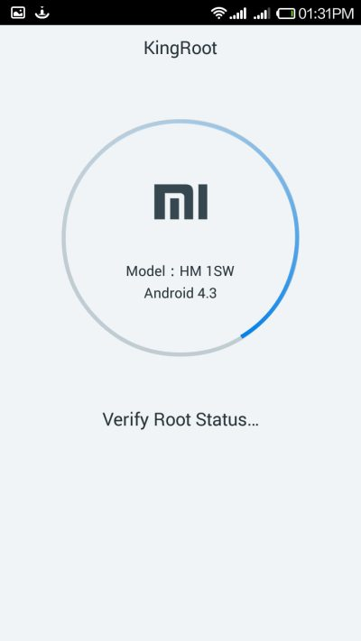
- Step 5: Tap on Try to Root.
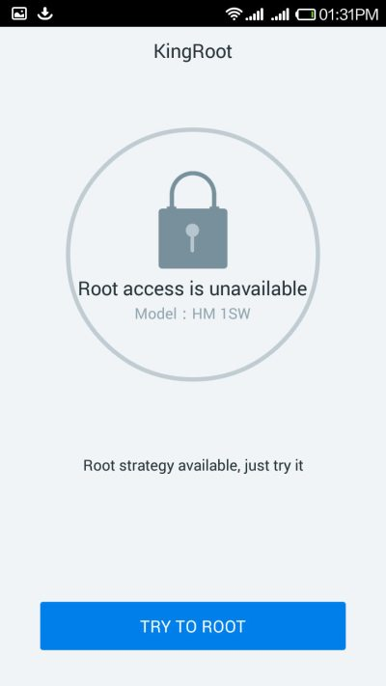
- Step 6: Wait for a few seconds as Kingroot tries to root your phone.
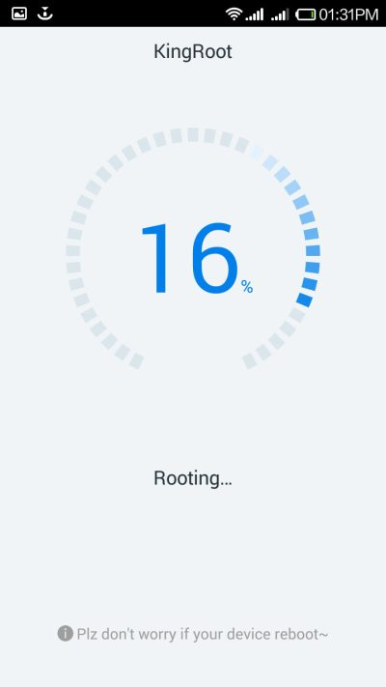
- Step 7: Once your phone is rooted, you will see a Root Obtained message under the crown logo.
Note:While doing this process mobile will be rebooting several times.
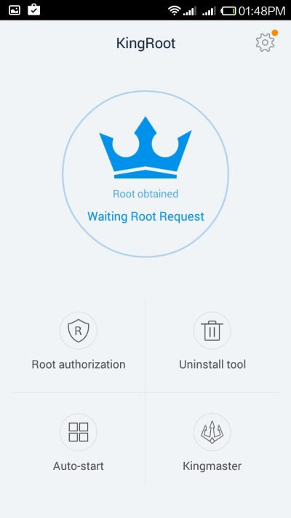
- Step 8: Now install the Root checker app from the Google play store and check whether your phone has been rooted or not.
If your phone has been rooted, you will see a similar message.
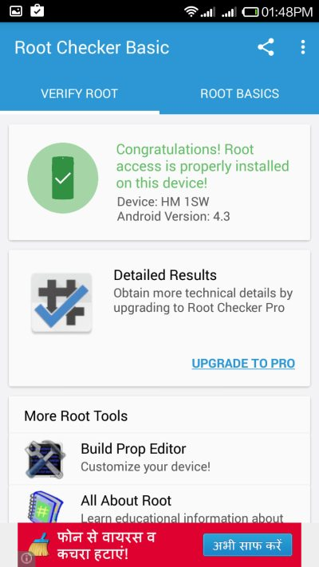
Once the mobile is rooted try to flash the mobile by using below procedure.

Backup Process:

Make sure your mobile is rooted:
1. Install Nandroid Backup



Online Nandroid Backup * ROOT
4,445
Thomas Otero (H3R3T1C) Tools
Unrated
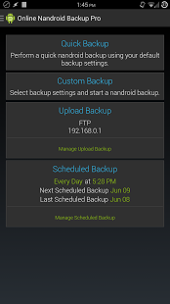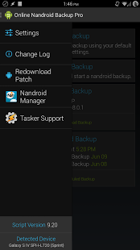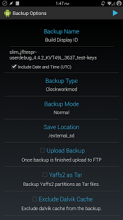
Nandroid backups are usually performed in recovery mode. This means you would have to turn off your phone and reboot in recovery mode, which wastes a whole lot of time rebooting and a lot more time offline. With this tool you can do nandroid backups without switching off your device.THIS APP REQUIRES A ROOTED DEVICE!
2. Go to setting and change the Backup location to SD card

settings-> default backup setting ->
change backup name(optional)
Backuptype-> clockworkmod
backup mode -> normal mode
save location -> /mnt/sdcard2(your wish but make sure the location is in the sdcard)

3. Quick Backup
(It takes several minutes)
once done it throughs a message that “sucessfully completed”
then you can find the back images in the corresponding location.

Better copy(Back files) to your PC using the adb commands which are listed below.

username@xyz:~$ adb devices
List of devices attached
HQ541YL17255 device

username@xyz:~$ adb shell
shell@htc_v02_dug:/ $
shell@htc_v02_dug:/mnt/sdcard2/clockworkmod/backup $ ls
2016-12-23.08.31.37
shell@htc_v02_dug:/mnt/sdcard2/clockworkmod/backup $ pwd
/mnt/sdcard2/clockworkmod/backup (copy the path)
shell@htc_v02_dug:/mnt/sdcard2/clockworkmod/backup $ exit
user@xyz:~$ adb pull /mnt/sdcard2/clockworkmod/backup/2016-12-23.08.31.37 ./inmypcbackfolder
pull: building file list...
pull: /mnt/sdcard2/clockworkmod/backup/2016-12-23.08.31.37/recovery.log -> ./recovery.log
pull: /mnt/sdcard2/clockworkmod/backup/2016-12-23.08.31.37/nandroid.md5 -> ./nandroid.md5
pull: /mnt/sdcard2/clockworkmod/backup/2016-12-23.08.31.37/uboot.img -> ./uboot.img
pull: /mnt/sdcard2/clockworkmod/backup/2016-12-23.08.31.37/system.ext4.tar -> ./system.ext4.tar
pull: /mnt/sdcard2/clockworkmod/backup/2016-12-23.08.31.37/recovery.img -> ./recovery.img
pull: /mnt/sdcard2/clockworkmod/backup/2016-12-23.08.31.37/data.ext4.tar -> ./data.ext4.tar
pull: /mnt/sdcard2/clockworkmod/backup/2016-12-23.08.31.37/cache.ext4.tar -> ./cache.ext4.tar
pull: /mnt/sdcard2/clockworkmod/backup/2016-12-23.08.31.37/boot.img -> ./boot.img
8 files pulled. 0 files skipped.
6778 KB/s (1833518263 bytes in 264.138s)
username@xyz:~$
(once copied check it in the destinationfolder)

YOU ARE DONE.......

FLASHING PROCEDURE (With new Stock Rom) USING ADB:

1. Download the flash image for HTC desire 526G+ from the below link.
https://drive.google.com/uc?id=0B04l-1rXfDyOU0lrN2lpZ21Ddzg&export=download

2. Extract the above downloaded file

3. Switch of the HTC mobile device
First Hold the volume UP button then Hold the Power button until it vibrate.
Once popup comes choose the Fast boot mode and enter(Volume down button).

4. Open terminal check the fastboot device with below command:\
$ fastboot devices
it shows the devices available in fastboot mode connected to the PC through USB.

5. Then enter below commands:
fastboot flash system system-sign.img (It takes much time. Dont disconnect)
fastboot flash boot boot-sign.img
fastboot flash userdata userdata-sign.img

6. Once the above commands done correctly. Reboot device using the below command
$ fastboot reboot

Flashing is done successfully
Now Switch on your Device..

Thanks

